Illustration Tool Test

# Illustrator

Illustrator is the tool I have had most exposer to in the past. I have used it for multiple different application and game designs. It allows for wonderful scaling assets that can be used very effectively as UI components.

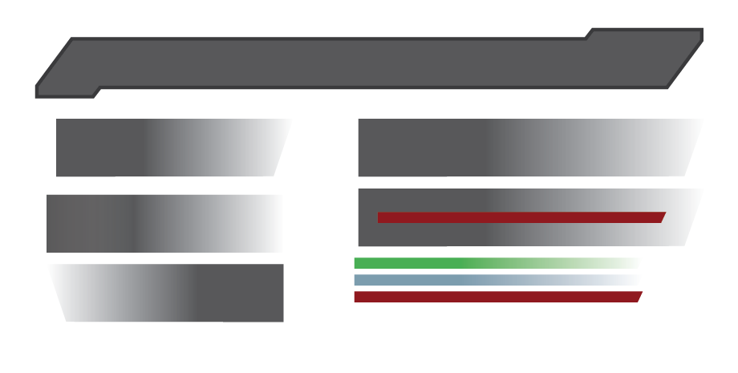

Here you can see me testing out some designs for the Health and Mana bars. Illustrator has the pen tool that allows for custom assests to be created opposed to restricted shapes like squares and ovals. The simple gradient tool can be applied to all of the elements on the canvas which adds another level of detail to the assets created.

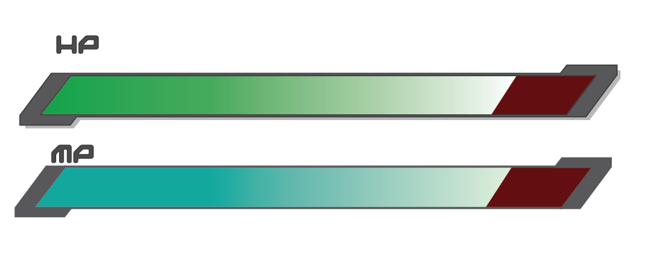

I then moved on to piecing the assets together. It was so easy to bring this together I am considering using it in the game itself. I can create multiple assets that all revolve around the same theme seeing as the base sprite sheet has been created.

# Photoshop

Photoshop is the only other tool I have decided to test as I don’t want to spend too much time on testing and designing assets that might not be used in the actual game. As I have already attempted to create assets that will be displaying the Health and Mana bars of a character, I thought it would be beneficial to test another UI section. The section I have chosen to create is perhaps the most important of them all being the menu system I intend to plug into the game.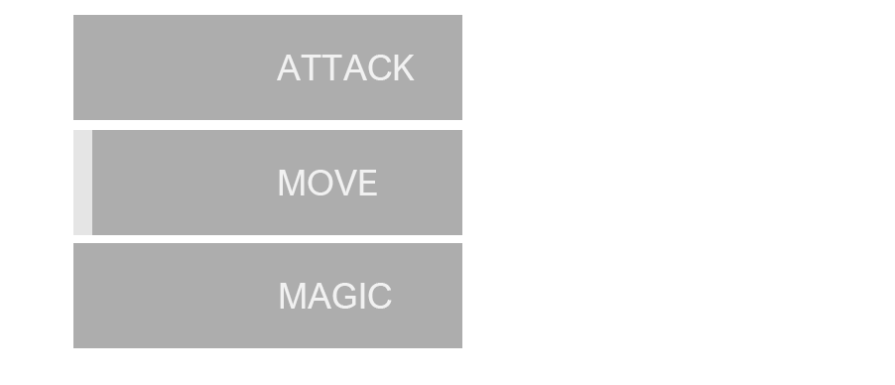The first asset created is very simple, yet it took much longer than I anticipated. This is mainly down to me not understanding how PhotoShop layers work and how to interact with the elements on each layer. However after the initial bump I was able to pull the next assets together rather quickly. The key feature I want to keep consistent throughout the game is the simplicity in assets and game play. Although the assets created on illustrator are a little more vibrant it was good to test out its potential.

One problem I encountered with PhotoShop is that the assets can be created from a range of shapes or drawn with the pen, brush or pencil tools. This would be a lot easier to do if I had assess to something like a drawing tablet, but creating custom shapes using only the mouse has limited the created quite a lot.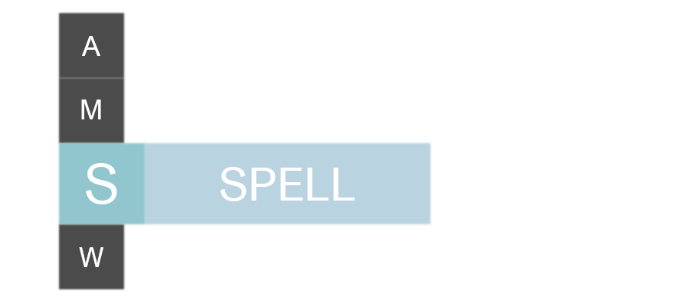

Next I was following the rules of simplicity, keeping the assets two a small amount of numbers, varying the opacity to give the effect of multiple shades and block based text. I really like how this design showcases the highlighted menu choice but I feel like it would have to be altered if I am going to use it in the game as the standalone letters aren’t clear to what they represent.

This being said I really like the design. I would like to play around with this design more and possibly test it in illustrator to see which is easier to complete and alter.

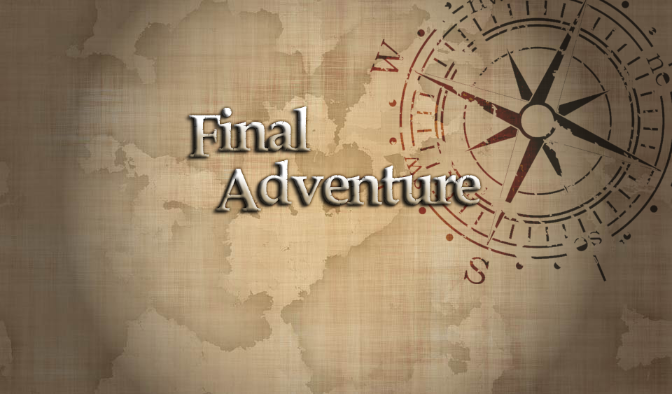

Finally I wanted to mock up a main menu design. Knowing that PhotoShop works well with multiple images and layering them on top of each other, I wanted to test this. It did take a series of google searches and youtube videos before I was able to understand how to burn an image into anothe, remove a specific colour from an image and add the torch like effect. I am really happy with how this turned out and realize that this is going to be a strong pull factor for using PhotoShop. I may even use this within the game, however it doesn’t match the UI designs I made earlier so either one will need changing.

# Conclusion

Overall both tools are extremely useful and I can see myself using both of them during the design stages of the game. This being said Illustrator was so much quicker in building and completing the assets. I spent a lot more time using PhotoShop as I didn’t know how to use it, but the learning curve the might prevent me from creating quality assets in a short amount of time is really the main deciding factor. If the UI takes a more artistic route I may revisit Photoshop, but for now using Illustrator is going to allow me to make simple custom images, whilst taking advantage of all the tools I already know how to use.